
RAMAIAH
Institute of Technology
USN | 1 | M | S

(Autonomous Institute, Affiliated to VTU)
(Approved by AICTE, New Delhi & Govt. of Karnataka) Accredited by NBA & NAAC with ‘A’ Grade

MAKEUP EXAMINATIONS – FEBRUARY 2020
Program | : | B.E.: Electrical and Electronics Engineering | Semester | : | VII
Course Name | : | Switchgear and Protection | Max. Marks | : | 100
Course Code | : | EE71 | Duration | : | 3 Hrs

Instructions to the Candidates:
- Answer one full question from each unit.

 |  | UNIT- I
1. | a) | What is an isolator? Bring out the classification of isolators? | CO1 | (05)
 | b) | A circuit breaker interrupts the magnetizing current of a 100 MVA transformer at 220 kV. The magnetizing current of the transformer is 5% of the full load current. Determine the maximum voltage which may appear across the gap of the breaker when magnetizing current is interrupted at 53% of its peak value. The stray capacitance is 2500 pF. The inductance is 30 H. | CO1 | (05)
 | c) | With a neat sketch, explain the construction and working principle of liquid type high voltage fuse. | CO1 | (10)
2. | a) | Briefly explain the concept of high resistance interruption and current zero interruption with respect to a circuit breaker. | CO1 | (06)
 | b) | State and explain fuse law. | CO1 | (04)
 | c) | With the help of a single line diagram representing fault condition and its equivalent circuit, derive an expression of restriking voltage and rate of rise of restriking voltage. | CO1 | (10)
 |  | UNIT- II
3. | a) | Explain the nature and causes of faults in a power system. Also discuss its consequences on power system. | CO1 | (08)
 | b) | An 11 kV, 500 MVA circuit breaker suddenly closes on to a fault. Determine (i) the symmetrical breaking current ii) the asymmetrical breaking current assuming 50% dc component (iii) the peak making current iv) the short time current rating. | CO2 | (07)
 | c) | What is the role of backup protection in power system protection? Briefly explain various methods of providing back-up protection. | CO3 | (05)
4. | a) | With a neat sketch explain the construction and working principle of minimum oil circuit breaker. Bring-out its advantages and disadvantages. | CO2 | (10)
 | b) | Discuss essential qualities of a protective relay. | CO3 | (05)
 | c) | Discuss how saturation affects the accuracy of CTs. Explain the accuracy limit factor or saturation factor. | CO2 | (05)
 |  | UNIT- III
5. | a) | With suitable sketches, explain the working principle of  i) Rectifier bridge type phase comparator ii) Time bias type phase comparator. | CO2 | (10)
 | b) | “Distance protection is superior to over current protection for protecting transmission lines”. Suitably justify the above statement. | CO3 | (05)
 | c) | With a neat sketch explain how the combination of directional and non directional relay can be used to protect a parallel feeders. | CO3 | (05)
6. | a) | Explain the following over current protection schemes:  i) Time graded system ii) Current graded system | CO3 | (10)
 | b) | Fig. 6(b) shows distance protection for a section of a power system. The I zone setting at A and B is 150 ohms.  i) What will be impedance seen by the relay at A for a fault at F₁? Will the relay at A operate before the circuit breaker at B has tripped?  (ii) Will the relay at B trip for a fault at F₁ before the circuit breaker at A has tripped?  (iii) If the circuit breaker C₂ fails for a fault at F₂, will the fault be cleared by relays at A and B?  (iv) How will the fault at F₂ be cleared?  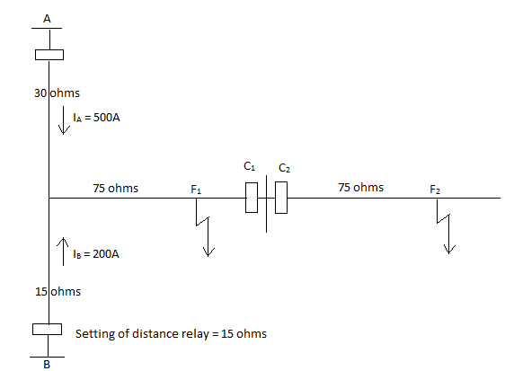  Fig. 6(b) | CO3 | (10)
 |  | UNIT- IV
7. | a) | Bring-out the probable reasons for unbalanced three phase stator currents in an alternator. How this unbalanced stator currents lead to overheating of rotor? Also explain how rotor is protected against overheating because of unbalanced three phase stator currents in the alternator. | CO4 | (07)
 | b) | With a neat sketch explain:  - Differential current protection of bus zone  - Frame leakage protection. | CO4 | (08)
 | c) | List the abnormal operating condition experienced by an Induction motor? How is it protected for these abnormalities during operation. | CO4 | (05)
8. | a) | A 50 MVA, 132/66 kV, Δ/Y, three phase power transformer is protected by percentage differential relay. If the C.T located on delta and star sides of the power transformer are 300/5A and 1200/5A respectively, determine:  i) The output current at full load  ii) The relay current at full load  iii) The minimum relay current setting to permit 25% overload.  Assume relay rating as 1A. | CO4 | (08)
 | b) | With a neat sketch explain the principle of balanced voltage wire pilot protection. Also draw the practical scheme employing balanced voltage principle. | CO4 | (08)
 | c) | With a neat sketch explain protection of earthing transformer. | CO4 | (04)
 |  | UNIT- V
9. | a) | With the help of a relevant diagram, explain how adoptive relaying can be used to reduce plug setting of the differential relay used for protection of a transformer. | CO5 | (08)
 | b) | Draw the block diagram of microprocessor based over current relay and explain. | CO5 | (08)
 | c) | Briefly explain the following:  i) Phasor Measurement Unit ii) Phasor Data Concentrator iii) Wide Area Measurements System. | Co5 | (04)
10. | a) | With the help of a flow chart, explain how a microprocessor based impedance relay can be realized. | CO5 | (10)
 | b) | With the help of a neat sketch explain how hierarchy is established between PMUs and PDCs to manage WAMS. | CO5 | (10)
****************

